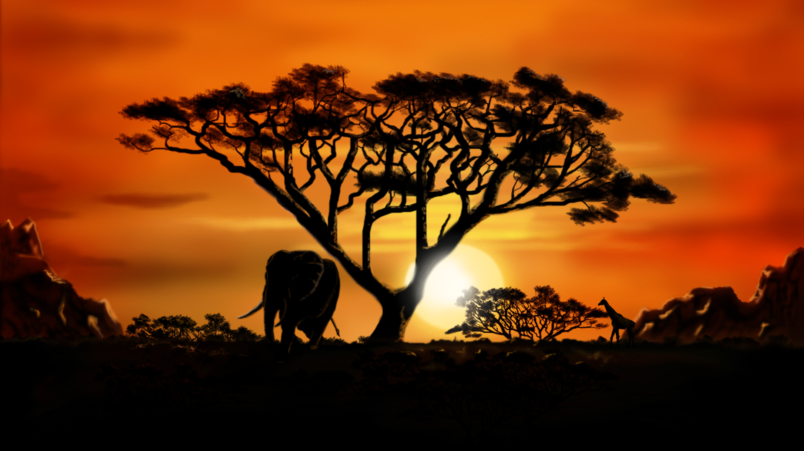
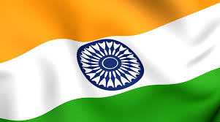
INDIA
Summer term 2015
Mathematics
SATs Revision
Numbers and fractions
Addition, subtraction, multiplication and division
Problem solving
Measure
Literacy
SATs Revision

Non-fiction: Biographies and report writing

Fiction: Script writing, film program writing and narrative writing

PSHE
Health & Safety
Injury Minimisation Programme for Schools (I.M.P.S) – Horton Hospital
Setting personal goals & facing new challenges
Sex education
History
Compare and contrast India and UK looking at religion, transport, food, animals, homes, clothes.

Sequence the historical periods they have studied from the Indus Valley civilisation to present day.
Describe how Mohenjo-Daro was organised and make comparisons with a town today.

Religious Education
Pentecost
Belonging to the Church community
Celebrating the life of Mary and the Saints
P.E.
Dance
Netball
Athletics
Computing
Film editing using online software
Algorithms and computer programming
Geography
Location of India

Physical and human features of India
Collect, record, present and analyse population data, using appropriate mathematical techniques, and draw conclusions

D&T / Art
Prepare Indian food dish and recipe
Rangoli patterns
Traditional Indian art

Music
Traditional Indian music
Instruments from around the world
Science
Revision of simple circuits
Hands on experience with symbols, diagrams & incomplete circuits
Compare series & parallel circuits
French
Pen Pals
Food
Revision of days of week/months
Weather

