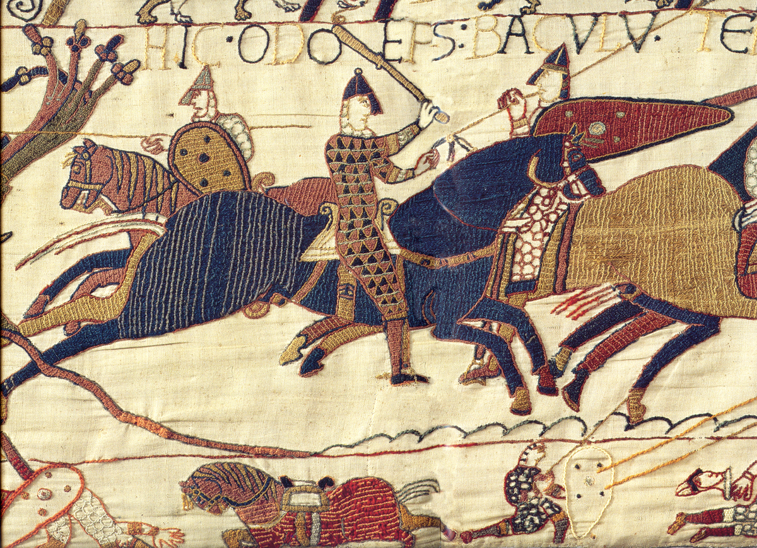

**COMPUTING**

In computing the children will learn about collaborative working and using shared documents; creating google docs and google slides. We will also be looking at how to create spreadsheets and google forms. In the second part of the term the children will be learning about coding and programming by using scratch.

**ENGLISH**

These are the text types we will be covering and the books that are linked to them.:

Narrative retelling (Based on the Legend of King Arthur and The Land of Tir na Nog)

Kennings (Anglo Saxons, King Arthur)

Diary entry (Linked to Remembrance)

Formal Letters (Charlie and the Chocolate Factory)

Chronological report (Based on extracts from the Boy by Roald Dahl)

Christmas poem (Free verse poem)

**MUSIC**

In the first half of the Autumn term, we will be studying the 70s pop group Abba. The children will listen to and appraise a range of their music. Throughout lessons the children will have an opportunity to develop their musical skills such as rhythm and improvisation. In the second half of the term the children will be learning how to play the glockenspiel, learning to play a range of simple melody’s and building on their understanding of music notation.

**ART**

This term in art we will be learning about surrealism through exploring the works of Magritte. Creating our own versions of his painting  La Décalcomanie using oil pastels.

DT

We will be learning about the key aspects of the design cycle. We will be creating a device help rescue a lost mountain climber. We will be using wires and electrical components to light up a bulb and make a buzzer activate.

**RE**

**The Story of the People of God –** We will develop our knowledge and understanding of the structure of the Bible. We will study stories of significant people in the Old Testament and discover what these stories tell us about their relationship with God.

**Jesus Teaches Us How To Pray**

The children will develop their understanding of different types of prayer and learn about how Jesus would have worshiped as a follower of Judaism. They will learn about traditional prayers of the church including the prayer of the Rosary.

**Advent –** The children will know that Jesus was descendent of the House of David through learning about the Jesse tree. They will recognise some stories about Jesus’ ancestors and how important their relationship with God was.

**Christmas –** We will develop our understanding of the events that surround the birth of Jesus and his cousin John the Baptist. The children will learn that angels are heralds of important messages and will consider how Christians today are heralds of the message of Christ.

**RSHE**

We will be covering the first unit from the TenTen programme, **‘Created and loved by God’**, which will cover healthy relationships, change and growth, and staying safe.

**FRENCH**

In French this term the children will be learning to listen and identify words and short phrases. They will learn to communicate by asking and answering a range of questions. The children will also memorise a short piece of text and will present it to the rest of the class.

**PE**

In our outdoor PE sessions, we will be learning about hockey. There children will build on their teamwork skills and will develop a good understanding of the key rules of field hockey. In our sessions the children will learn about the range of different techniques used to move the ball around the pitch.

In indoor PE the children will be participating in circuit training sessions. In these sessions the children will learn about the different areas of muscle in the body. The children will take part in a range of different exercises and activities.

Quest for the Kingdom

**HISTORY**

In history this term we will be looking at the Anglo Saxons, Vikings and Norman Invasion of 1066. We will explore the reasons that these groups of people came to England. Through exploring Anglo Saxon place names, we will learn of the influence this group of people had on the country. We will also look at how the Vikings navigated the North Sea and settled in Britain, investigating their homelands and the events that lead to their invasion of England. Towards the end of the term, we will explore the events of 1066 leading and the contest for the English throne.

**Geography**

We will investigate what features create a suitable settle for group of people, making reference to human and physical features. The children will look at the different countries in Europe and will be able to name the different climate Zones

**SCIENCE**

**States of Matter**

In this unit the children will learn about the states of matter: Solids, Liquids and Gases. We start by looking at atoms, molecules and particles and how they move in the different states of mater. Later in the term, we will look at Carbon Dioxide as a case study and how it is produced and used around the world.

**Electricity**

In the second half the term we will begin to look at electricity. The children will understand how electricity is caused by a flow of electrons. We will investigate which materials are conductive and which are insulators.

|  |
| --- |
|  |
|  |

**MATHS**

**Column Addition and Subtraction**

Learning how to fluently add and subtract numbers with up to 4-digits.

**Place Value**

Being able to recognise the value of each digit in a 4-digit number. Calculating 1000 more or less than a given number. Counting in 25s. Recognising and counting into negative numbers. Recognising numbers up to 10,000.

**Perimeter**

Understanding how to calculate the perimeter of a range of 2d shapes. Understanding the properties of regular polygons

**3,6, and 9 Times Tables.**

Representing the 3,6 and 9 times tables.

Recalling the number facts from the 3, 6 and 9 times tables

Calculating division problems by using the inverse.

Recognising the relationships between the 3, 6 and time stables.