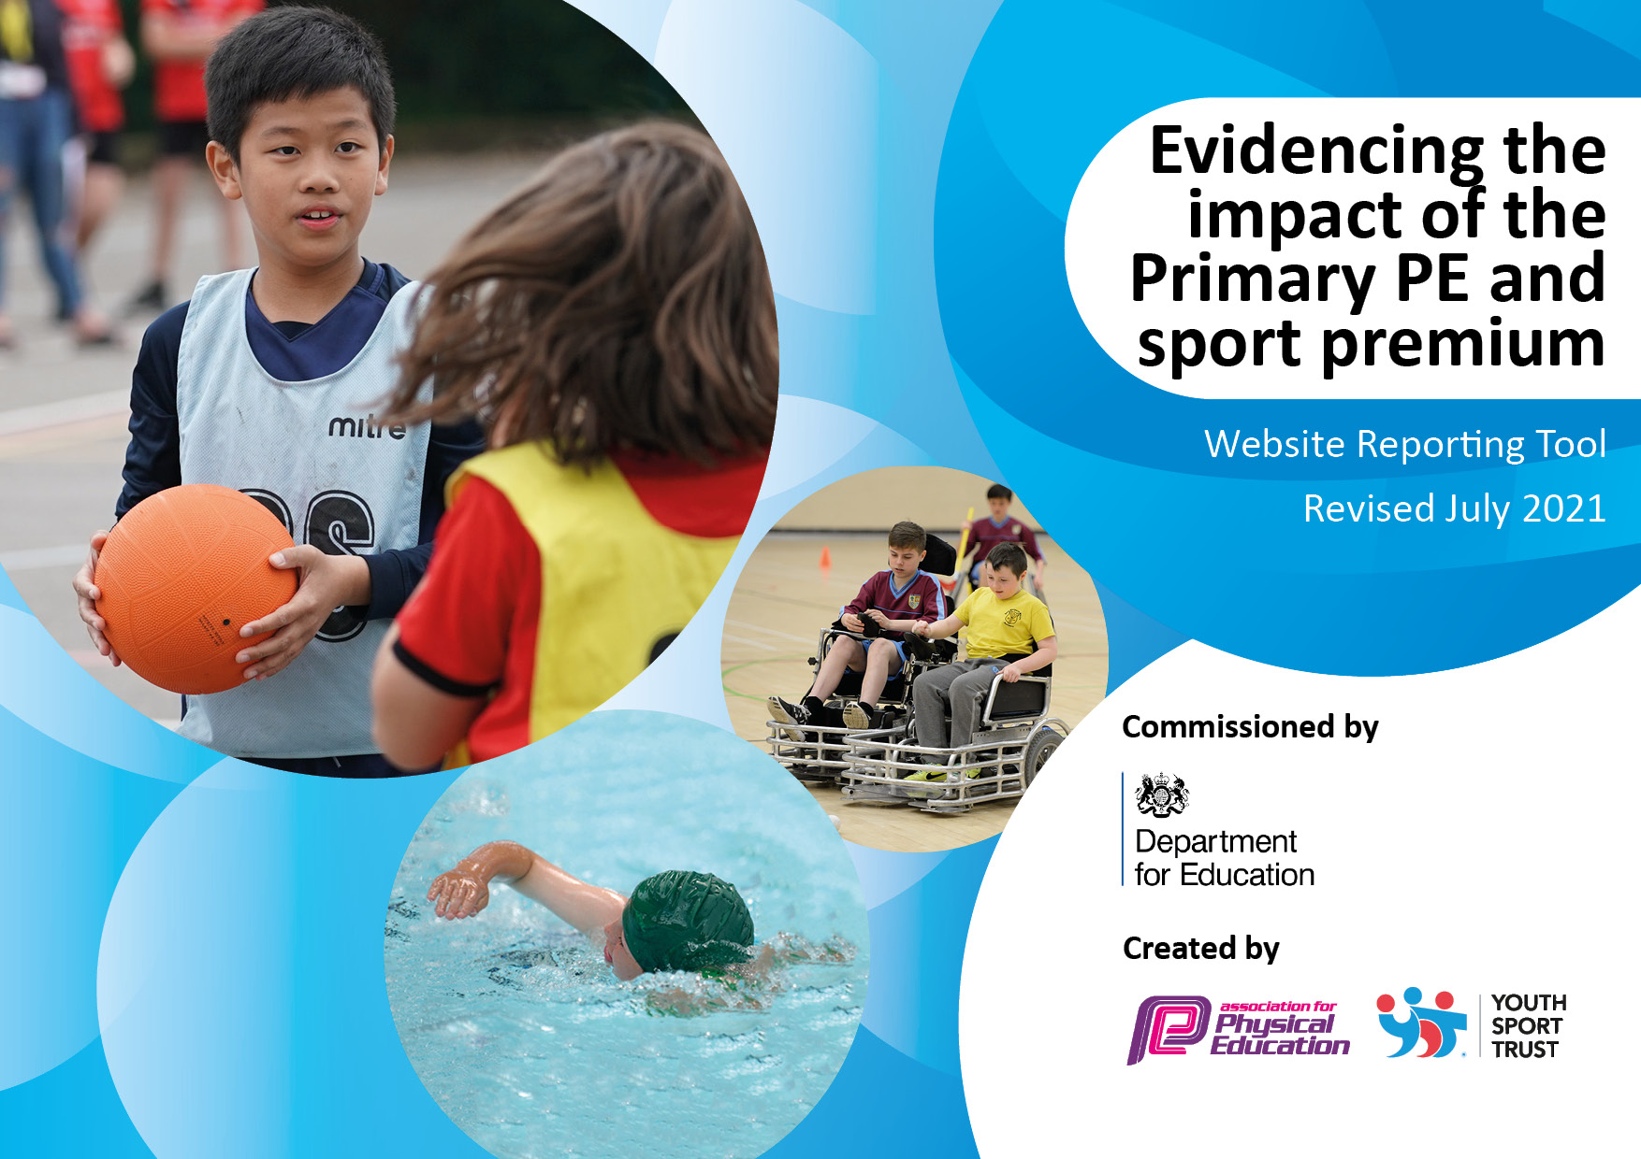

Revised July 2024

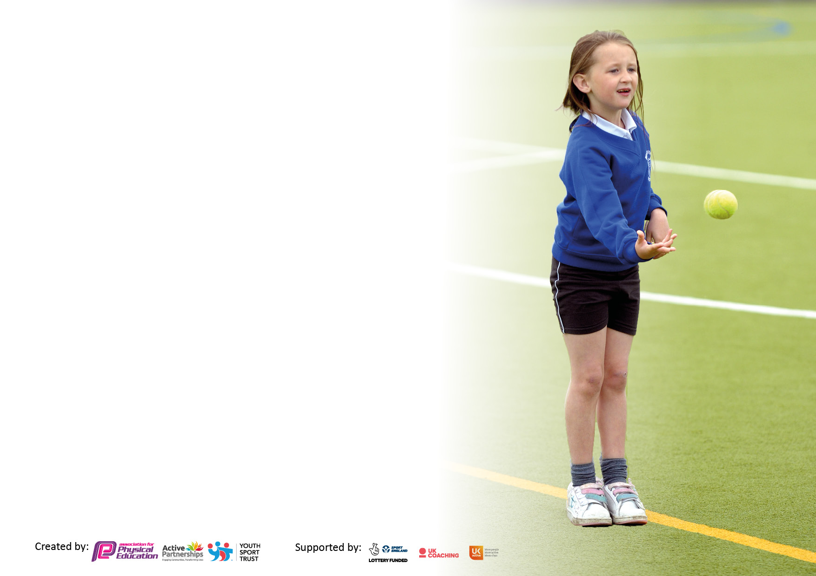

It is important that your grant is used effectively and based on school need. The [Education Inspection Framework](https://assets.publishing.service.gov.uk/government/uploads/system/uploads/attachment_data/file/843108/School_inspection_handbook_-_section_5.pdf) makes clear there will be a focus on **‘whether leaders and those responsible for governors all understand their respective roles and perform these in a way that enhances the effectiveness of the school’**.

Under the [Quality of Education](https://assets.publishing.service.gov.uk/government/uploads/system/uploads/attachment_data/file/843108/School_inspection_handbook_-_section_5.pdf) Ofsted inspectors consider:

**Intent** - Curriculum design, coverage and appropriateness

**Implementation** - Curriculum delivery, Teaching (pedagogy) and Assessment

**Impact** - Attainment and progress

To assist schools with common transferable language this template has been developed to utilise the same three headings which should make your plans easily transferable between working documents.

Schools must use the funding to make **additional and sustainable** improvements to the quality of Physical Education, School Sport and Physical Activity (PESSPA) they offer. This means that you should use the Primary PE and sport premium to:

* Develop or add to the PESSPA activities that your school already offer
* Build capacity and capability within the school to ensure that improvements made now will benefit pupils joining the school in future years
* The Primary PE and sport premium should not be used to fund capital spend projects; the school’s budget should fund these.

Pleasevisit[gov.uk](https://www.gov.uk/guidance/pe-and-sport-premium-for-primary-schools)fortherevisedDfEguidanceincludingthe5keyindicatorsacrosswhichschoolsshoulddemonstrate animprovement.Thisdocumentwillhelpyoutoreviewyourprovisionandtoreportyourspend.DfEencouragesschools to use this template as an effective way of meeting the reporting requirements of the Primary PE and sport premium.

We recommend you start by reflecting on the impact of current provision and reviewing the previous spend.

Schools are required to [publish details](https://www.gov.uk/guidance/what-maintained-schools-must-publish-online#pe-and-sport-premium-for-primary-schools) of how they spend this funding, including any under-spend from 2019/2020, as well as on the impact it has on pupils’ PE and sport participation and attainment. **All funding must be spent by 31st July 2022.**

We recommend regularly updating the table and publishing it on your website throughout the year. This evidences your ongoing self-evaluation of how you are using the funding to secure maximum, sustainable impact. Final copy must be posted on your website by the end of the academic year and no later than the 31st July 2021. To see an example of how to complete the table please click [HERE](http://www.afpe.org.uk/physical-education/wp-content/uploads/afPE-Example-Template-Indicator-2018-Final.pdf).



**Details with regard to funding**

Please complete the table below.

|  |  |
| --- | --- |
| Total amount carried over from 2022/23 | £0 |
| Total amount allocated for 2023/24 | £18,000 |
| How much (if any) do you intend to carry over from this total fund into? | £0 |
| Total amount allocated | £17,800 |
| Total amount of funding. | £21,800 |
| Total amount of Funding carried forward | £0 |

**Swimming Data**

Please report on your Swimming Data below.

|  |  |
| --- | --- |
| Meeting national curriculum requirements for swimming and water safety.  N.B. Complete this section to your best ability. For example you might have practised safe self-rescue techniques on dry land which you can then transfer to the pool when school swimming restarts.  **Due to exceptional circumstances priority should be given to ensuring that pupils can perform safe self rescue even if they do not fully meet the first two requirements of the NC programme of study** | £2,000 |
| What percentage of your current Year 6 cohort swim competently, confidently and proficiently over a distance of at least 25 metres?  **N.B.** Even though your pupils may swim in another year please report on their attainment on leaving primary school at the end of the summer term 2020.  Please see note above | 96 % |
| What percentage of your current Year 6 cohort use a range of strokes effectively [for example, front crawl, backstroke and breaststroke]?  Please see note above | 96 % |
| **What percentage of your current Year 6 cohort perform safe self-rescue in different water-based situations?** | 90 % |
| Schools can choose to use the Primary PE and sport premium to provide additional provision for swimming but this must be for activity **over and above** the national curriculum requirements. Have you used it in this way? | No |

**Action Plan and Budget Tracking**

Capture your intended annual spend against the 5 key indicators. Clarify the success criteria and evidence of impact that you intend to measure to evaluate for pupils today and for the future.

|  |  |  |  |  |
| --- | --- | --- | --- | --- |
| **Academic Year:** 2023/24 | **Total fund allocated:18,000** | **Date Updated: July 2024** | |  |
| **Key indicator 1:** The engagement of all pupils in regular physical activity – Chief Medical Officers guidelines recommend that primary school pupils undertake at least 30 minutes of physical activity a day in school | | | | Percentage of total allocation: |
| 25% |
| **Intent** | **Implementation** | | **Impact** |  |
| Your school focus should be clear what you want the pupils to know and be able to do and about  what they need to learn and to  consolidate through practice: | Make sure your actions to achieve are linked to your intentions: | Funding allocated: | Evidence of impact: what do pupils now know and what can they now do? What has changed?: | Sustainability and suggested next steps: |
| Continue to work with the Chipping Norton Partnership (CNP) to embed fitness and fundamental skills in weekly practice. For the benefit of both the pupils and teachers.  To continue to train Upper Key Stage 2 children to become young sports leaders Engage with local clubs to increase the number of Holy Trinity pupils attending these clubs.  Continue training for the KS1 teacher in Forest School | Baseline and interval for fitness and fundamentals to measure impact.  Promote activity and fitness by regularly testing pupils’ fitness levels.  Upper Key Stage 2 children to become better Sports role models within the school.  Year 1 teacher to continue to attend training and implement Forest School across KS1 and EYFS.  Supply teacher | £3,895  £1000  £1500  £1000 | Children are able to develop their personal best and challenge themselves to have a go and persevere at anything they set their mind on.  During breaktimes all children are active and participate in a range of activities that enable them to be active.  All children in Year 1 has had the opportunity to participate in Forest School. | Maintain links with CNPS through attending Termly Meetings to enable full engagement at all events.  Continue to work with UKS2 children to develop their sports leadership skills.  Develop Forest School Provision within EYFS and KS1 to enable children to have opportunities to participate in LOTC.  All children will have participated in Forest school during their time at Holy Trinity |
| **Key indicator 2:** The profile of PESSPA being raised across the school as a tool for whole school improvement | | | | Percentage of total allocation: |
| 9% |
| **Intent** | **Implementation** | | **Impact** |  |
| Your school focus should be clear what you want the pupils to know and be able to do and about  what they need to learn and to  consolidate through practice: | Make sure your actions to achieve are linked to your intentions: | Funding allocated: | Evidence of impact: what do pupils now know and what can they now do? What has changed?: | Sustainability and suggested next steps: |
| Children to participate in the CNP competitions  Encourage the school to plan in movement breaks throughout the day to enable children to actively develop physical activity naturally into their routines.  Children to have the chance to represent the school in Sports | Enable children to participate in Events calendar by providing adequate staffing to ensure children are able to access the competitions.  Communicate with teaching staff to ensure coverage of curriculum as well as prepare children for competitions.  Signpost staff to resources to enable them to develop movement breaks within their classroom.  Coach travel to county finals | £1,700  £2400 | Across KS2 all children have had an opportunity to participate in a CNP Competition  Within the classroom teachers are using movement breaks frequently to ensure children are continually active.  PE board in hall to celebrate achievements as well as handing out participation certificates during celebration assembly. | Continue links with CNPS to enable all children to have an opportunity to take part in competitions.  Children to have movement breaks scheduled throughout the day to ensure that they are active in the classroom.  Further develop enthusiasm with the children by creating a Sports Award for children being active/participating in sports. |

|  |  |  |  |  |
| --- | --- | --- | --- | --- |
| **Key indicator 3:** Increased confidence, knowledge and skills of all staff in teaching PE and sport | | | | Percentage of total allocation: |
| 31% |
| **Intent** | **Implementation** | | **Impact** |  |
| Your school focus should be clear | Make sure your actions to | Funding | Evidence of impact: what do | Sustainability and suggested |
| what you want the pupils to know | achieve are linked to your | allocated: | pupils now know and what | next steps: |
| and be able to do and about | intentions: |  | can they now do? What has |  |
| what they need to learn and to |  |  | changed?: |  |
| consolidate through practice: |  |  |  |  |
| Sport coaches to upskill teachers in acquiring skills and knowledge to deliver quality first PE lessons.  Leadership time for PE Leader to attend partnership meetings.  Invest in Real PE. | Invite Sports Coaches to develop teacher confidence at delivering specific sports within their sports curriculum.  Attend half-termly CNPS meetings to maintain close working relationships with CNPS and West Oxfordshire Hub. | £500  £4120  £1200 | Teachers were able to participate in a Cricket Taster Session where professional coaches led a session for their class followed by an After-School CPD session to help teachers develop their confidence at Cricket Delivery within their sports curriculum.  Teachers feel empowered to develop their PE lessons to support children’s  Attended 8 out of 13 sessions of Sports Events provided by CNPS, plus 3 finals. | Continue to actively seek opportunities for Sports Coaches to deliver CPD/support to teachers to enable them to upskill their skill set.  Further develop links with CNPS to enable teachers to share best practise. |
| **Key indicator 4:** Broader experience of a range of sports and activities offered to all pupils | | | | Percentage of total allocation: |
| 9% |
| **Intent** | **Implementation** | | **Impact** |  |
| Your school focus should be clear | Make sure your actions to | Funding | Evidence of impact: what do | Sustainability and suggested |
| what you want the pupils to know | achieve are linked to your | allocated: | pupils now know and what | next steps: |
| and be able to do and about | intentions: |  | can they now do? What has |  |
| what they need to learn and to |  |  | changed?: |  |
| consolidate through practice: |  |  |  |  |
| Children to participate in the CNPS competitions Increase in extra curricula clubs Children to attend forest school Improve links with local sports clubs  Additional achievements:  Re-engage with the School Games Mark to help raise the | Seek external support to help provide children a taster/sessions which enable them to have access to a broad range of sporting opportunities.  Use School Games Mark tracker to monitor provision of sports and to help develop awareness of how to further improve participation in a range of sports. | £3005 inc. Above | Children in KS1 and KS2 have had an opportunity to access specialised session provided by CNPS PE teachers.  Achieved a Gold School Games Mark which demonstrates the school is recovering from COVID-19 restrictions. | Encourage further engagement of participation in sports competitions.  Welcome opportunities for KS2 to participate in Forest School as an opportunity for LOTC.  Continue to maintain Gold School Games Mark and aim for platinum as part of a long term plan. (Platinum only achievable through consistently holding Gold Mark for four consecutive years). |

|  |  |  |  |  |
| --- | --- | --- | --- | --- |
| **Key indicator 5:** Increased participation in competitive sport | | | | Percentage of total allocation: |
| 11% |
| **Intent** | **Implementation** | | **Impact** |  |
| Your school focus should be clear | Make sure your actions to | Funding | Evidence of impact: what do | Sustainability and suggested |
| what you want the pupils to know | achieve are linked to your | allocated: | pupils now know and what | next steps: |
| and be able to do and about | intentions: |  | can they now do? What has |  |
| what they need to learn and to |  |  | changed?: |  |
| consolidate through practice: |  |  |  |  |
| All children to participate in CNP competitions and skills workshops.  Organise whole school sports day ensuring that parents see the importance of children participating in sport.  Children to have the opportunity to experience School Games during PE Lessons with inter-house competitions. | Actively engage with CNPS Calendar to enable children to have access to a wide range of competitive sport.  Engage staff to help plan a sports day where all children are encouraged to participate and live out the School Games Values.  Develop an inter-house competition within half-termly PE Lessons.  Additional Sporting equipment | £2400  £500  1,000 | Attended 9 out of 13 sessions of Sports Events provided by CNPS.  Staff Meeting dedicated to planning Sports Day – Parental feedback received expressing the successes of Annual Sports Day post-COVID.  Teachers beginning to introduce inter-house competitions at the end of their Sports delivery to ensure children develop the skill set specific to different sports. | Continue to engage with CNPS to enable children to access a plethora of sports events.  Continue to involve staff during planning and preparation of Sports Day.  Organise Termly Inter-Year Group Sport competitions to further raise the profile of sports provision. |

|  |  |
| --- | --- |
| Signed off by | |
| Head Teacher: | Lorna Buchanan |
| Date: | July 2024 |
| Subject Leader: | James Whybrow |
| Date: | July 2024 |
| Governor: | Pauline Brookes |
| Date: | July 2024 |