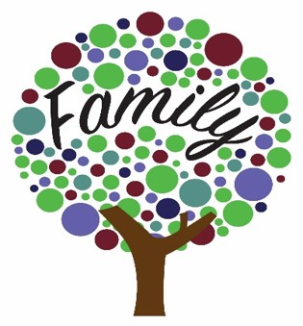

**Early Help**

This is a support for Children and Families. The Early Help Offer is a pathway to supporting you and your child as they grow up when you or they may need further support or guidance. Providing early help to our pupils and families means we can improve outcomes for children, families, and communities, providing support as soon as a problem emerges, at any point in a child’s life, from the early years through to teenage years.

Early Help can support children and their families who may be struggling with:

* Routines and family rules
* Families who may not be eating healthy food
* Keeping to a healthy lifestyle
* Children who are caring for a family member
* Children who may not want to go to school for different reasons
* Disability within the family including children being a young carer
* Children in the family have special educational needs (SEND)
* Children who may becoming involved in anti-social or criminal behaviour
* Children who go missing from home
* Children or parents / carers misusing drugs or alcohol
* Children at risk of being tricked, forced, or made to work in the criminal world
* Children who may need support because they may live in a home and see drug or alcohol abuse or adult mental health problems.
* Children who have parents who argue a lot (and sometimes might hurt each other) whether the parents live together or apart.
* Children at risk of being groomed to join groups which support illegal views
* A privately fostered child (a child from another family living within your family home)

Early help relies upon local groups and people in the community, sometimes we work together to help children, young people, and their families. Everyone needs help at some time in their lives and therefore an ethos of early help is important for any school. Below are some of the services available to all our families at any time. There is a range of support for health and well-being.

**Online Safety**

If you have concerns around the safety of your child or a child you know online, the following links will provide you with information, support, and advice to help understand the risks and keep your child safe online:

* https://www.thinkuknow.co.uk/parents/
* Online safety | Barnardo's (barnardos.org.uk)
* http://educateagainsthate.com/
* www.internetmatters.org
* https://www.bbc.com/ownit/the-basics/8-tips-for-staying-safe-online
* <https://www.nspcc.org.uk/keeping-children-safe/online-safety/>

**Relationships**

The following services and links offer information, advice, and intervention on healthy relationships for your family and children:

Healthy relationships | NSPCC

**SEND (Special Educational Needs and/or Disabilities)**

Oxfordshire SEND Local Offer provides comprehensive information on support available for children with SEN and their families. This includes educational support, activities, and local support groups for parents and carers. If you click ‘local support for your child’ and ‘local support for you’ it brings up a long list of signposting for both local support but also national charity with helplines.

[Find SEND support 5 to 15 | Oxfordshire County Council](https://www.oxfordshire.gov.uk/residents/children-education-and-families/oxfordshire-send-local-offer/parents-carers/children-aged-5-15/find-send-support-5-15)

Oxfordshire Parent Carers Forum is a community where parents and carers can connect, share experiences, and access support. They also have a Facebook group for sharing information and events related to children with SEN [Home | OxPCF](https://www.oxpcf.org.uk/)

<https://www.oxfordshire.gov.uk/residents/children-education-and-families/oxfordshire-send-local-offer>

Early Help in Oxfordshire have created a booklet to help families find out about the help

and support available in the county for children and young people aged 0-18 years old. The

new booklet will help you and families find the most appropriate support.

To download this booklet, please visit:

<https://www.oscb.org.uk/wp-content/uploads/2023/08/Early-help-guide-for-families-Sept-2023.pdf>

**Health (including mental health and emotional wellbeing)**

Safe Haven - Oxfordshire Safe Haven is open every day for people who are experiencing a mental health crisis.

<https://www.oxfordshiremind.org.uk/support-for-you/safe-haven/>

Find a dentist

<https://www.nhs.uk/service-search/find-a-dentist>

Should I keep my child off school?

<https://www.nhs.uk/live-well/is-my-child-too-ill-for-school/>

Kooth is an online mental wellbeing community which offers free, safe, and anonymous support.

Home - Kooth

School Health Nursing

<https://www.oxfordhealth.nhs.uk/school-health-nurses/primary/>

**Finance, Housing and Employment**

If you are facing challenges around employment and income,

please contact the local job centre who can with offer support with jobseekers’ allowance, incapacity benefit, employment and support allowance and income support.

<https://www.jobcentreguide.co.uk/banbury-jobcentre>

<https://www.jobcentreguide.co.uk/witney-jobcentre>

**The Chippy Larder**

Our aim is to alleviate (and prevent) poverty in Chipping Norton (and surrounding areas) and promote physical and mental health (one of the prime impacts of poverty).  Due to the types of services that we are planning on offering we will also have a positive side impact on the environment and on community cohesiveness as a whole.

The majority of our services are targeted at low-income households, currently via referrals from local schools, councils and organisations although some services are available to all.  The Chippy Larder’s offerings are split into four areas that we aim to concentrate on i) Food, ii) Finance, iii) Fitness and iv) Futures.

We are a secular and non-judgemental service provider. We have a board of trustees as well as a core team of regular volunteers and a much larger pool of ad-hoc volunteers that we can call upon.

Our patron is the High Sherriff of Oxfordshire, Amanda Ponsonby, who takes an active interest and is regularly in attendance at our events.

Opening Hours: Thursdays from 1 - 6pm

The Guildhall, Market Place, Chipping Norton, OX7 5NJ

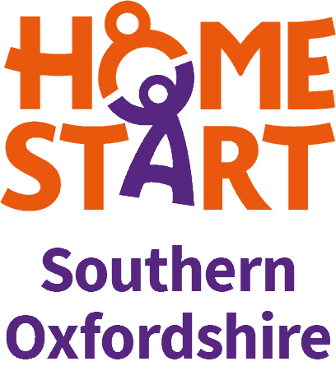

<https://home-startbanbury.org.uk/>

Home-Start Banbury, Bicester & Chipping Norton is a local charity which provides emotional and practical support to parents with at least one child under five years old.

We are an independent charity affiliated to [Home-Start UK](http://home-start.org.uk/), the country’s leading family support charity. Our volunteers are all parents and are trained, supported and supervised to Home-Start UK standards.

Our aim is to provide early support to families who are facing the challenges and stresses of family life, including a wide range of difficulties such as isolation, low self-esteem, physical and mental health issues.

We work alongside parents in their homes to help raise their self-confidence and their ability to cope in an increasingly pressured society. Our emphasis is on parents helping parents.



<https://livewell.oxfordshire.gov.uk/>

**Parenting Support**

Chipping Norton Parent Pals

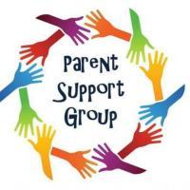

<https://fisd.oxfordshire.gov.uk/kb5/oxfordshire/directory/service.page?id=pUqP8k-ixF4>

Chipping Norton Parent Pals is a local support group for parents and carers of children that suffer from mental health, ASD, anxiety or depression.

*We meet every last Tuesday of the month in the Town Hall in Chipping Norton from 7-9pm*

We will have a speaker at each session talking about a range of issues around mental illness, eating disorders, self harm, coping with anxiety and so much more.

Have you previously been through mental health issues with your child? Please come along and chat to other parents to pass on your experiences, knowledge and ideas. Is your child anxious or depressed and you just need some guidance and a bit of support?  Your child doesn't need to have a diagnosis or be waiting for a referral... The group is there for everyone!

<https://www.chippingnortontheatre.com/take-part/adults/parent-support-groups>



<https://www.chippingnortonhealthcentre.nhs.uk/mental-health-and-well-being-resources-for-young-people/>



<https://www.thebranchtrust.org/seeking-support>

<https://www.thebranchtrust.org/>