

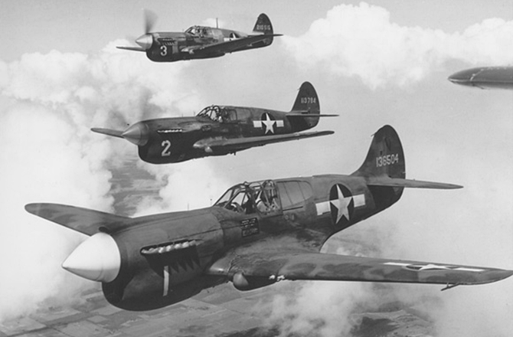
WWII
Autumn term 2015
Mathematics
Place value and written addition
Decimals and written addition
Subtraction
Shape and angles
Multiplication, division and fractions
Measures including time
Literacy
- Recounts
- Diary entries
- Biographies and autobiographies
- Poetry

Class texts:
Goodnight Mister Tom
The Diary of Anne Frank

PSHE
New beginnings

Getting on and falling out

Anti bullying week
(16th-20th Nov)

History
Use a variety of sources to find out facts about WW2
Find out about how the war affected the lives of ordinary people
Explore reasons for the war

Understand which countries were involved in WW2

Learn key dates and leaders of WW2

Religious Education
The story of the people of God
Followers of Christ
Advent
Christmas
P.E.
Football
Hockey
Swimming
Dance/Gym
Computing
- Designing and creating algorithms

- Programming

Geography
Use maps to identify countries involved in WW2

Identify where the countries of the allies and the axis were

D&T / Art
Design a wartime meal using rations
Observational drawings of objects from the period
Design a propaganda poster
Christmas stockings

Music
- Explore popular WW2 music
- Explore music the troops listened to
- KS2 Christmas carol Service

Science
Animals including humans
Electricity
French
Classroom routines
Clothes vocabulary
Family members
Occupations

